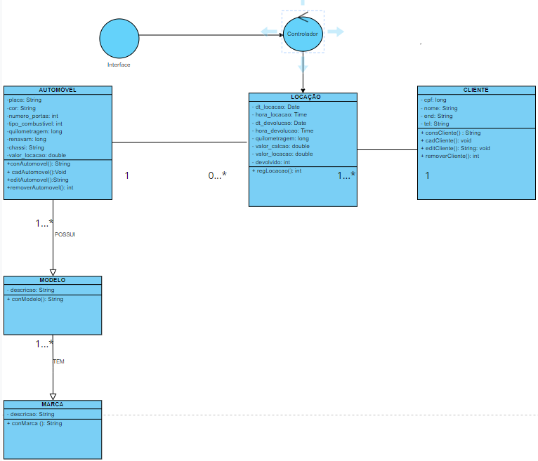

https://drive.google.com/file/d/1FRwbvKpw0kicN8KUrlzVJc2N6t2y0_LL/view?usp=drive_link

